Name: _____________________________________

Score: _________/25

Reaction Time Assessment

1. What was your hypothesis?

(1 mark)

2. Identify the independent and dependant variables in this investigation

(2 marks)

3. Identify THREE extraneous (uncontrolled) variables, or any other sources of error in this experiment. Describe how you could control each variable.

(3 marks)

4. Do you think your hypothesis was supported:
a) by the overall data? Explain

(1 mark)
b) by all individuals within the data? Explain.
(1mark)

5. Scientists need to be mindful of the practise effect in experiments such as this one.
What do you think the practise effect is?

(1 mark)

6. To find out if your experiment was affected by the practise effect, plot your data for three members of your group for their 5 trials for the “Before” or “Normal” situation on the grid below (Hint. Trial number is on the horizontal axis).
(3 marks)
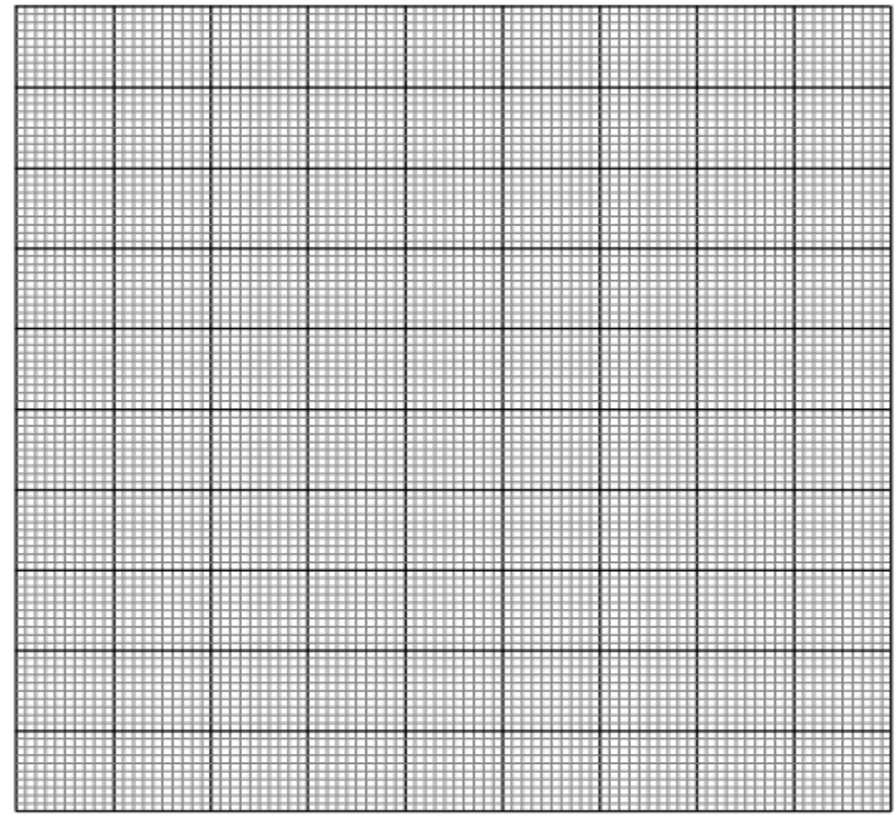

7. Using evidence from your graph to decide if you data have been affected by the practise effect.

(2 marks)

8. What are the overall median and the range of the data from all data displayed on the graph above? Explain how you calculated each one.

(4 marks)

9. Define validity and comment on the validity of your experiment.

(2 marks)

10. a) Define reliability.

(1 mark)
b) How could you determine whether your data was reliable?

(1 mark)

c) Would you consider your experiment to be reliable?

(1 mark)

11. Safety of the participants in an investigation should be considered before the trials begin by conduction of a risk assessment.
Were there any risks involved in your investigation? Explain.
If not, describe an independent variable which might involve risks to the participants.

(1mark)

12. In the reaction being tested in your investigation, there are 3 types of neuron involved. Describe the role of each type in the transmission of the nerve impulse from the stimulus to the response.

(6 marks)

